The Battle of Neighborhoods – Mumbai

# Introduction - Background

Mumbai – previously known as Bombay, is the capital city of the state of Maharashtra in India. It is the financial capital of the country and one of the most populous cities in the world. In 2008, Mumbai was added to the list of alpha cities in the world. The city is known to be the hub to various businesses and one of the main tourist attractions in the Indian subcontinent. Mumbai has been estimated to attract more than 6 million tourists every year.

# Problem Statement

Dessert is the most enjoyed part of the food and everyone around the globe enjoys a nice dessert. Since a lot of tourists visit Mumbai every year and they would want to enjoy a good dessert, it would be a great idea to open a dessert bar in the city. However, there are some clusters where there already are too many dessert places or locations which do not receive huge tourist crowd. The aim of this project is to segment and cluster different neighborhoods in Mumbai to find a suitable location to open a dessert place.

# Data

Web scrapping can be used to collect data from openly available sources. For this project, raw data about the different neighborhoods of Mumbai is collected from [this](https://en.wikipedia.org/wiki/List_of_neighbourhoods_in_Mumbai) Wikipedia page. Mumbai can be segmented into 4 districts namely Western Suburbs, Eastern Suburbs, Harbor Suburbs, and South Mumbai. These districts are further segmented into 93 unique areas/neighborhoods. The latitude and longitude data for each of these neighborhoods, collected using Foursquare location data, is used to segment and cluster data for Mumbai city. Once the required data is collected, it looks like the following:

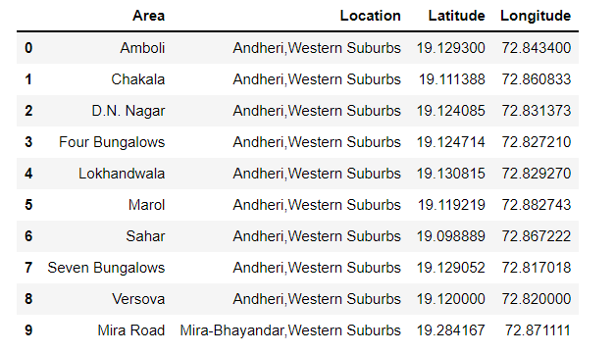

where the ‘Area’ corresponds to the different neighborhoods, and the location corresponds to different segments in districts.